**CUCUMBER**

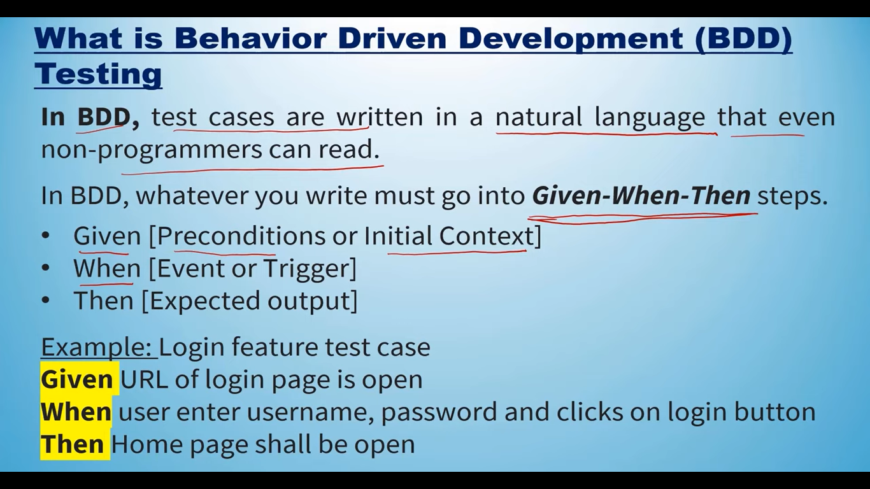

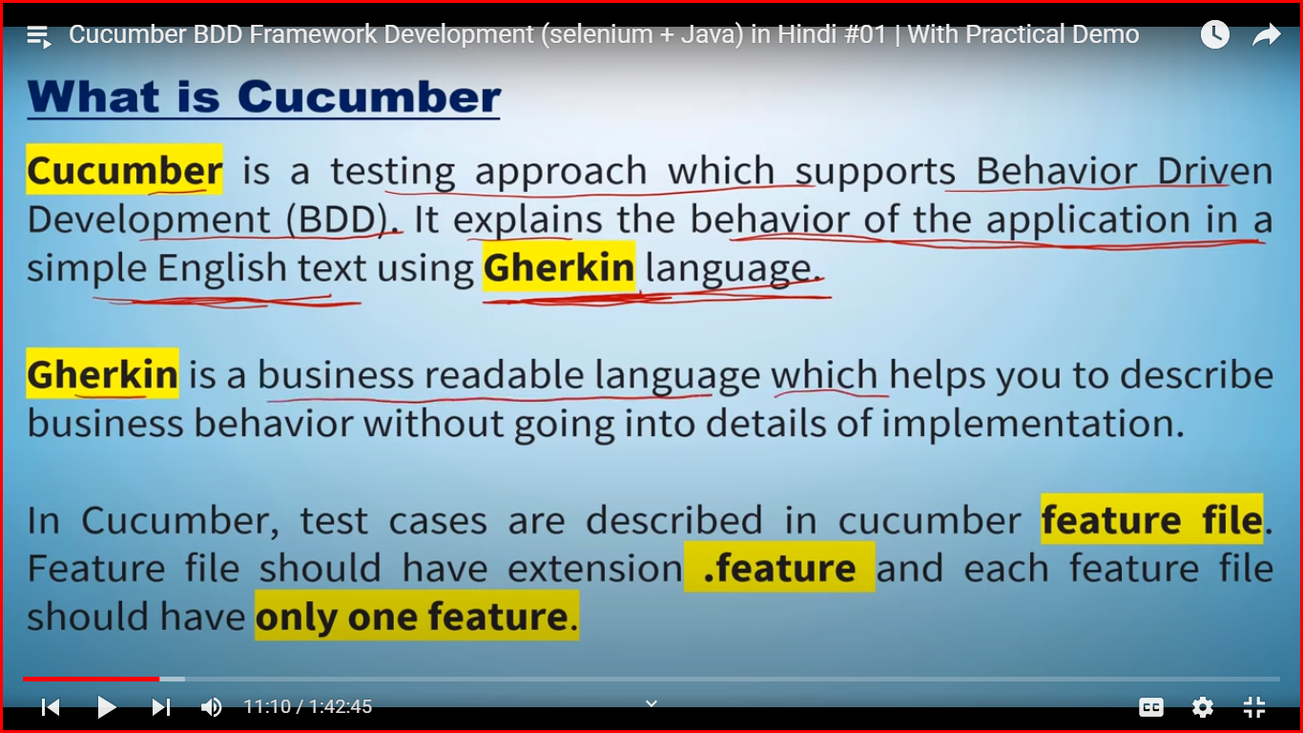

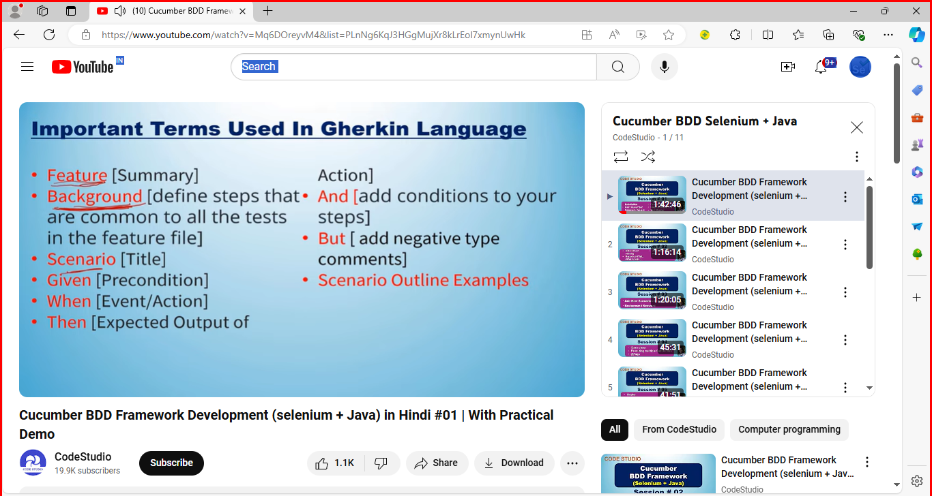

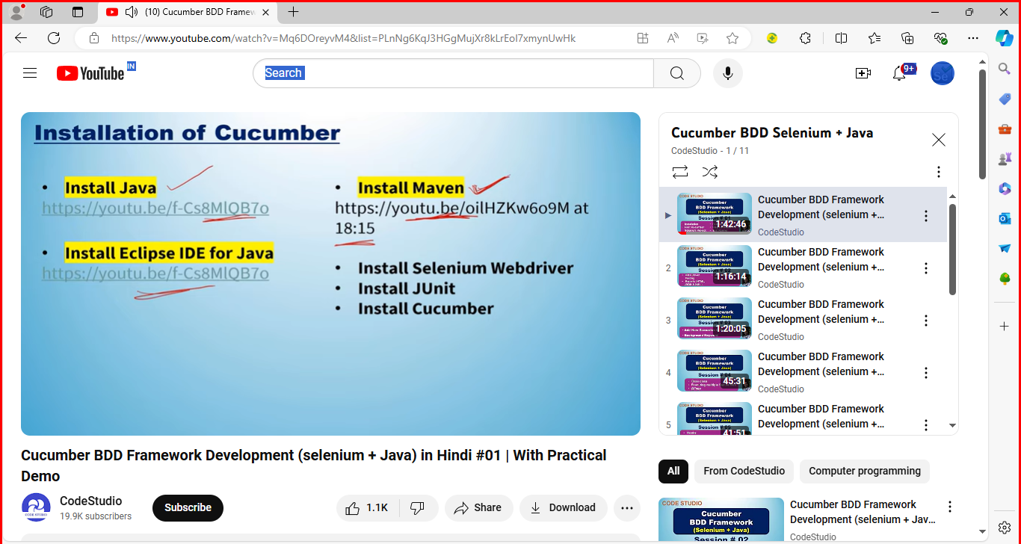

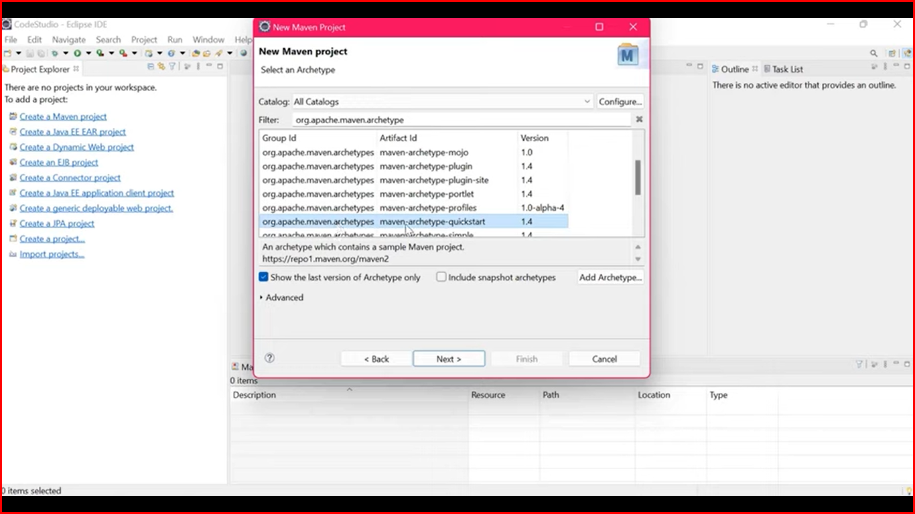

**To Download Cucumber eclipse plugin**

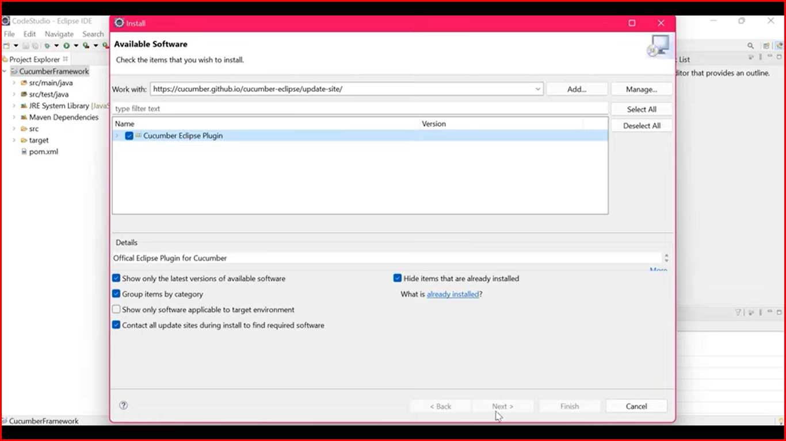

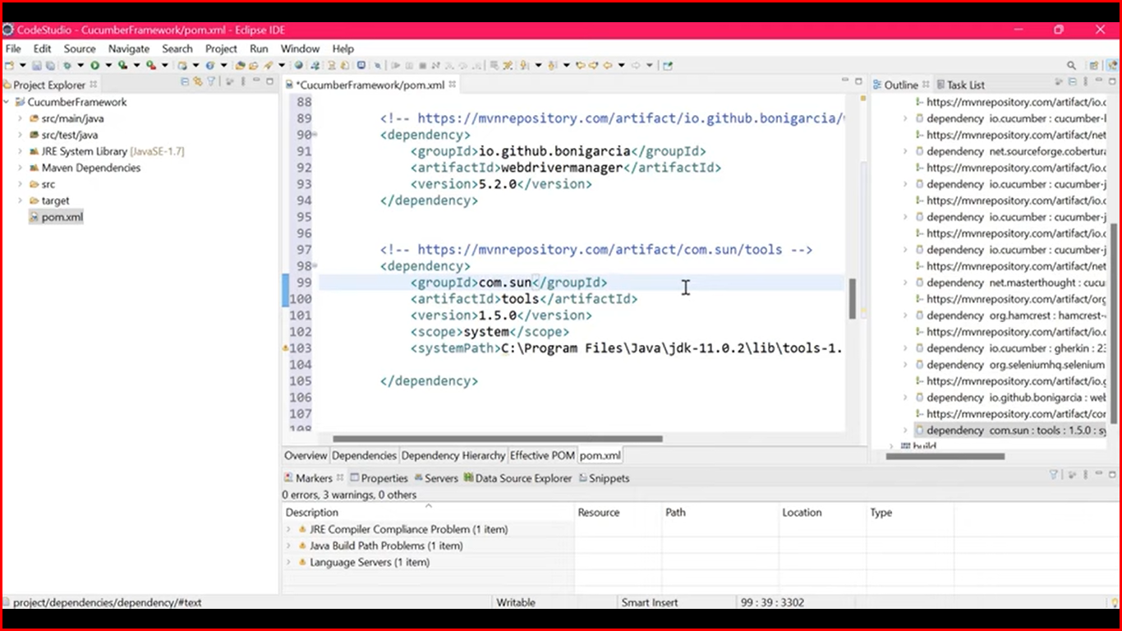

**Cucmber-java – 7.3.4**

**Cucmber-jvm-deps-1.0.6**

**Cucucmber-junit-7.3.4**

**Cucumber-reporting-5.7.1**

**Cucumber-html – 0.2.7**

**Corbetura – 2.1.1**

**Gherkin-23.0.1**

**Selenium-java – 4.2.1**

**Webdrivermanager-5.2.0**

